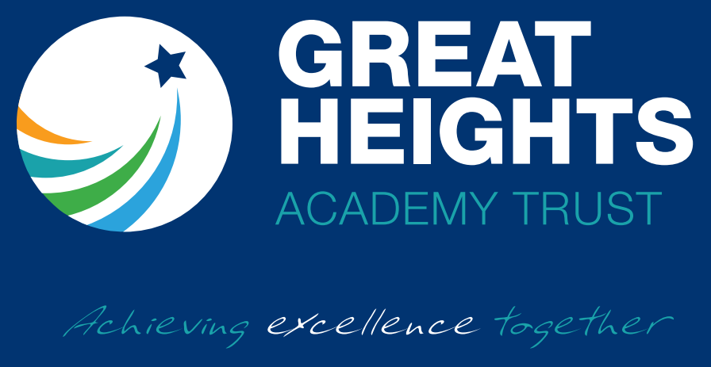
School Improvement Strategy 2023/2024

School Improvement Strategy Contents

Vision, Values and Aims | 3
Our Strategic School Improvement Key Strands | 4 & 5
The School Improvement Team | 6
School Improvement Strategy and Delivery Model | 7
Categorisation Criteria | 8
School Improvement Support and Challenge | 9

Our Vision and Values Statement
The Great Heights Academy Trust strives to always provide an inspirational, positive and welcoming environment where there is a sense of pride and fun and where everyone works together with confidence, enthusiasm and mutual respect. We aim to nurture academic, personal, spiritual and social development in a caring and professional manner so that all achieve their full potential and all can reach GREAT heights.
Our Trust vision has school improvement at its heart that will benefit all children in Trust schools.

Aims
We aim to:
• Develop an effective partnership of schools that share a commitment to raising standards
• Strengthen the partnership by valuing the uniqueness of each school and expecting all schools to contribute
• Foster relationships based on mutual respect with a balance of autonomy and accountability
• Share expertise – both best practice and best practitioners
• Develop all teachers and leaders through effective professional development.

GHAT School Improvement Strategic Key Strands

GHAT Strategic Key Strands in detail
Good knowledge of the needs and challenges faced by each Trust school | A forensic analysis of need is carried out through systematic and rigorous monitoring and evaluation of all major aspects to enable any issues to be found and appropriate support/intervention to be planned and implemented:  • Effectiveness of leadership and management, including safeguarding  • Quality of curriculum offers  • Standards of behaviour and attitudes  • Personal development  • Appropriateness of the curriculum  • Effective use of data to inform improvements which are securely evidence-informed monitoring methods adapt to changing needs with a calendar of offers and support including typicality visits, internal audits and stakeholder questionnaires.
Good knowledge of how to support each Trust school | We recognise that schools will need different types of support at different stages of their improvement journey. School self-evaluation will be moderated to ensure that priorities are accurately identified and support is bespoke and appropriate. The Trust will then allocate personnel accordingly from our directory of expert practitioners that we have available across out Trust academies. At the same time, we will be mindful of the need to get the right balance between maximising internal expertise and knowing when to draw on external help and challenge, both from individuals and schools outside the Trust. We contract a Trust school improvement partner, with Ofsted inspection experience, to provide quality assurance for our work. In addition, we continue to promote the use of evidence-based research, such as that provided by the Education Endowment Foundation, for whom we have led several projects in recent years.
Effective development and deployment of leaders and expertise | The quality of school leaders is paramount in driving school improvement forward. We aim to identify the best leaders and practitioners, at all levels, and deploy that expertise across the Trust. We run development programmes for emerging, middle and senior leaders. Their strategic deployment will help to accelerate improvement across the Trust and we will build up a strong pool of talent for the future to ensure that the raised standards are sustained over time. In addition, we will support the induction and training of effective governors and trustees under the guidance of our Director of Governance. .
Investment in joint professional development of staff | A key factor in improving teaching, learning and pupil progress is effective CPD and wellbeing support for our staff. We invest in our staff so that our staff can invest in our pupils. In addition to our work with individual schools, joint inset and twilight sessions are available to maximise CPD opportunities. We empower subject leaders to work together, moderate standards and share good practice. We support classroom staff to work together in clusters and offer coaching and mentoring opportunities. Our CPD offer is underpinned by the work of our Research School and English Hub.
Monitoring progress and tracking impact | The progress of all Trust programmes are monitored and their impact is tracked. This requires the adoption of robust implementation plans with clear outcome indicators from each academy. We also enable a series of summary dashboards so senior leaders and governance can easily spot challenges and barriers. Internal and external reviews and peer MAT processes ensure that these expectations are tracked and supported to enable all to build educational quality. Our overall aim is that all Trust academies can rapidly move forward in their school improvement journey trajectory.

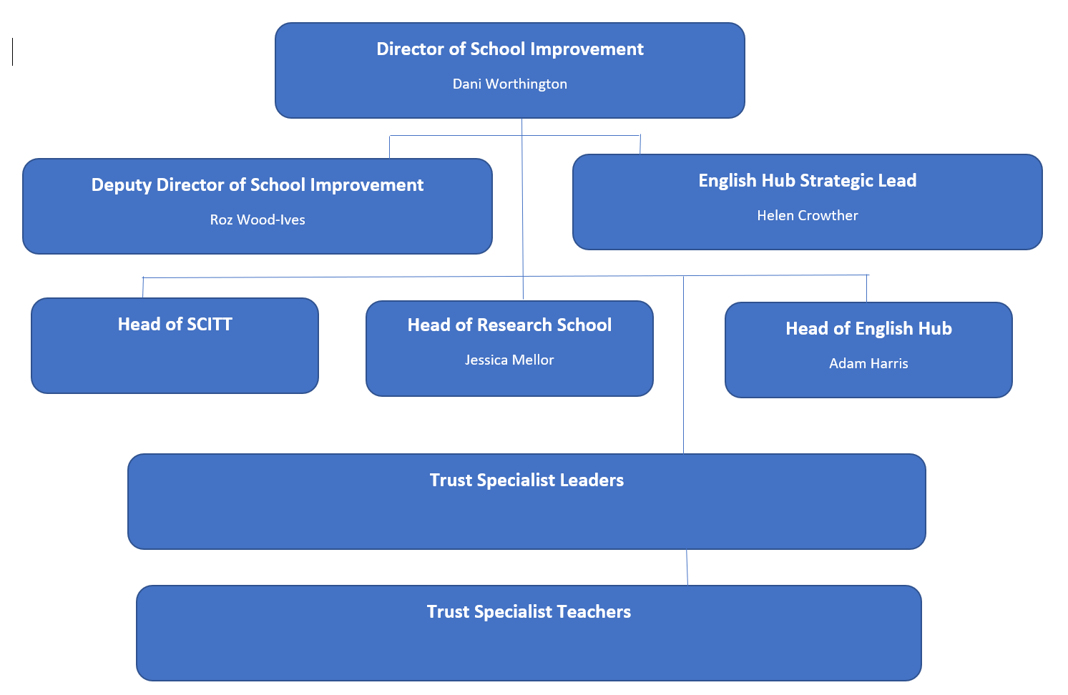
The School Improvement Team

The School Improvement Strategy Delivery Model

GHAT Quality Assurance Framework- the trust QAF outlines how the trust supports and holds schools to account through frequent reviews in key areas such as compliance, safeguarding, teaching and learning, attainment and data review, staff and parent views.
STABALISE |  | IMPROVE
Descriptor:  Schools who have been placed in a category or with an Academy Order. Schools joining the Trust who self-evaluate as being at risk of entering a category. |  | Descriptor:  Schools that have identified their priorities have a leadership structure in place to support improvements across the school.
Key Features | SI Team Engagement | Key Features | SI Team Engagement
- Capacity within the leadership team  - Curriculum not meeting the needs of all learners  - Lack of systems and processes to support quality assurance  - Attainment and progress measures are likely to be below national averages | - Termly Typicality Visits  - Termly quality assurance of pupil progress and attainment  - Termly External QA from Trust SI Partner  - Annual AIP/SEF QA  - Annual PP/Sports Premium Plan QA  - Bespoke plan of intensive support  **Academy to move to ‘improve’ within 1 year** | - Significant CPD in place using evidence informed practices  - New curriculum in place  - New systems and processes in place  Attainment and progress measures are likely to be improving towards national averages | - Termly Typicality Visits  - Termly quality assurance of pupil progress and attainment  - Termly External QA from Trust SIP  - Annual AIP/SEF QA  - Annual PP/Sports Premium Plan QA  - Bespoke coaching and mentoring plan agreed.  **Academy to move to ‘embed’ within 2 years**
EMBED |  | SUSTAIN & INNOVATE
Descriptor:  School using evidenced led practice to offer an excellent quality of education with an ambitious and well-designed curriculum underpinned by consistent pedagogical approaches. Leaders are clear in their vision with the drive and commitment to ensure QFT becomes embedded. Some leaders may support other schools to improve. |  | Descriptor:  Schools using evidence led practices to offer an excellent quality of education. Sustain schools have built on their embedding stage and are innovative in their approach, see themselves on a continuous journey and have the expertise and capacity to support other schools to improve.
Key Features | SI Team Engagement | Key Features | SI Team Engagement
- Research informed practice  - Shares best practice across the Trust and may deliver external school to school support  - Beginning to grow leaders at every level  - Attainment and progress measures are likely to be consistently in line or above national averages | - Termly Typicality Visits  - Termly quality assurance of pupil progress and attainment  - Termly External QA from Trust SI Partner  - Annual AIP/SEF QA  - Annual PP/Sports Premium Plan QA  **Academy to move to ‘sustain’ within 2 years** | - Research informed practice  - Shares best practice across the Trust and delivers external school to school support  - Grows leaders at every level  - Attainment and progress measures are likely to be consistently above averages | - Termly Typicality Visits  - Termly quality assurance of pupil progress and attainment  - Termly External QA from Trust SI Partner  - Annual AIP/SEF QA  - Annual PP/Sports Premium Plan QA

Categorisation Criteria

School Improvement Support and Challenge

Why do we ensure support and challenge?
Great Heights Trust believes that all of our trust schools should have a continuous focus on school improvement and that all leaders should have high aspirations and expectations for all pupils. We believe we are all on a continuous journey to know more and remember more. Our current offers now extend to our 2-18 broader trust development.

Through our ‘Continuous Quality Improvement’ offer (CQI) we support a forensic analysis of need in each school and a linking differentiated support approach at each of the varying stages of an academy improvement journey. Our academies all share common values including promoting a climate for learning which promotes effective learning behaviours and a broad variety of teaching approaches. The Trust’s workforce development team enables academy staff to engage with evidence, make informed research decisions and create a culture of reflection to ensure teachers, managers and leaders are as good as they can be in what and how they teach. This is a 2-18 offer with a national workforce development delivery footprint from our Research School and English Hub.

We feel it is important to provide assurances through appropriate challenge, our continuous quality improvement offer is further supported through our ‘Continuous Quality Assurance’ offer (CQA) where termly the MAT CEO and external partner meet to quality assure the ongoing school improvement work, provide support and challenge whilst holding senior leadership to account. Findings, next steps and celebrations of successes are reported to senior leaders at each academy who in turn share with their Local Governing Bodies for comment and are part of the CEO reporting to the trust board.
What is our school improvement support and challenge offer?
CQI – Continuous Quality Improvement
- Understanding need, leading a culture of improvement and building capacity for improvement
- Ensuring academies curriculum is ambitious in design and matched to meet the needs of the pupils in order to prepare them for their next stage of learning
- Quality assurance of senior and middle leader accuracy of judgements through joint termly monitoring
- Providing a coaching and mentoring offer to senior leaders
- Supports academies in evaluating the impact of specific pedagogies and interventions
- Deployment of workforce development team through MAT internal offer
- Deployment of commissioned support following identification of need
- Analysis of academies use of assessment and moderation.

CQA – Continued Quality Assurance
- Quality assuring the CQI processes
- Ensures leadership through moral purpose
- Understanding all academies both quantitatively and qualitatively
- Holding Senior Leaders to Account
- Support, challenge and agreement with self-evaluation form
- Support, challenge and agreement with school improvement plan
- Ensures Governance Structure and skills retain focus on school improvement.

Workforce Development
- Includes Research School, English Hub and SCITT providing both internal and external offer of school improvement
- Offers evidence based professional learning
- Provides capacity to recruit, develop and retain talent
- Provides opportunities for leaders to support their career progression with involvement in national programs
- Has teams of designated system leaders with specialisms in different areas and teaching phases
- Support with principled curriculum design
- Encourages, assesses and supports scaling up of innovation
- Designs and delivers high quality programmes and support
- Supports and empowers middle leaders as leaders of teaching.

Who provides our school improvement, support and challenge offer?
We are uniquely placed with our own dedicated internal teams who support our academies to ensure school improvement including workforce development is prioritised, in summary;
- Trust board with school improvement and leadership experience at all phases
- Dedicated standards committee with oversight of school improvement support and challenge
- Linkng chairs of local governing bodies network which provides local oversight and support materials
- Dedicated Director of Governance for leadership support
- Dedicated Director of School Improvement with a team including primary and secondary academy leaders, executive leaders, workforce development teams and post holders for current initiatives
- Academy leaders, Deputy Head and subject coordinator forums.

When is our school improvement, support and challenge offer provided?
A calendar of events is designed annually with continuous support for CQI and workforce development alongside termly CQA including:
- Forensic assessment of data, a supported MAT assessment systems and processes
- Annual SDP (AIP) joint planning with support and planned offers from our workforce development teams
- Termly networks of leaders and managers to learn with and from each other
- Continuous opportunities to be part of research trials and roll out of latest innovations
- Set half termly CQI joint events with SI team support
- Set termly CQA events with SI team support for any external challenge
- Timetabled events to match governance reporting timelines and DfE expectations.

What is Typicality?
The purpose of our typicality week is to provide a snapshot of what is typical across our classrooms. These weeks take place termly where members of each Senior Leadership Team will visit lessons across the week and triangulate what is seen with work in books, pupil interviews and school data. Members of the school improvement team will provide quality assurance of the processes during typicality week.
All typicality monitoring activities will provide evidence against the Teaching Standards and evidence of the implementation of the school’s curriculum. Areas for development are jointly agreed and a package of support is commissioned where necessary which includes bespoke CPD offers and coaching and mentoring arrangements from School Improvement Team members and/or Trust Specialist Leaders of Education and Trust Specialist Teachers.

School Improvement Team Trust Support Package

