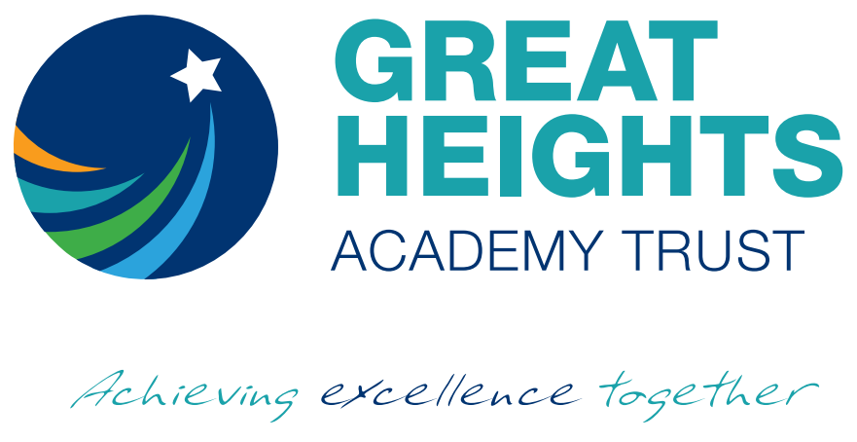
Great Heights Academy Trust
School Street, Greetland HX4 8JB
Telephone: 01422 372893
Website: www.westvaleacademy.org.uk

Required as soon as possible
1:1 Learning Support Assistant for a child with a with a Visual Impairment
(based at West Vale Academy, Stainland Road, Halifax, HX4 8LS)
Scale 2, Full-Time or Part-Time job share considered, Term-Time only

34 hrs per week Salary £14,721

‘Great Heights Academy Trust strives to always provide an inspirational, positive and welcoming environment
where there is a sense of pride and fun and where everyone works together
with confidence, enthusiasm and mutual respect’

Why should you come and join our team?
West Vale Academy’s promise to our children is that we will attract, retain and develop excellent staff and so the personal welfare and professional development of staff is paramount to us. We believe that our team should be at the heart of our vision and that we should use their talents to achieve our goals: you could be an integral part of this team.

We require a caring, enthusiastic and dedicated Learning Support Assistant. The post is to support a child with a visual impairment and is subject to the named pupil’s continued education at the school. Experience of supporting pupils with Special Educational Needs is essential.

Generally, to work under the direct instruction of teaching/senior staff, usually in the classroom with the teacher, to support access to learning for pupils. Specifically, this may be to:

- Work within the classroom to support the learning needs of the child
- Provide targeted 1:1 and group interventions as required
- Adapt support dependent on the pupils’ needs - communication, patience and understanding.
- Create a stimulating environment in which their learning and development is encouraged,
- Keep records of the child’s progress and provide information that will help teachers with their progress
You will:

* have a clear understanding of the ways in which children learn and a range of effective teaching styles which meet the children's individual needs
* be confident in your ability and work with initiative
* work well within a team, be keen to share ideas and happy to take advice from colleagues and specialist staff
* be keen to develop skills further by completing training signposted by key leaders, including Braille training.
* be determined to make a positive difference to the young people at Westvale Academy
* be able to smile a lot and model high expectations of yourself and others
* be caring, friendly, adaptable and hardworking
* experience of working with a child with a visual impairment would be advantageous, although desirable as training and support will be available

In return we offer the successful applicant:

* wonderful children with a desire to learn
* a calm, caring environment where children are well-behaved
* a highly skilled, loyal and supportive team of staff and senior leaders
* bespoke professional development to ensure that you as an employee, ‘reach great heights’
* supportive and proactive parents who will work with you to make sure their children succeed

Great Heights Academy Trust is committed to safeguarding and promoting the welfare of children, young people and vulnerable adults and expects all staff to share this commitment. Applicants to posts that are exempted from the Rehabilitation of Offenders Act will require a DBS (formerly CRB) from the Disclosure and Barring Service, the appropriate pre-employment checks that will include references from previous employers, confirmation of the right to work in the UK before the appointment is confirmed.
The Trust is committed to ensuring security and protection of personal data, in line with the Data Protection Act 2018 (DPA) and General Data Protection Regulation (GDPR). Personal data will be used for the purpose of recruitment and employment processing.
If you would like to learn more about the post, please download our application pack from
https://greatheightstrust.org.uk/employment-opportunities/

Please return your completed application form by email to Katherine Humphreys, HR Manager: k.humphreys@greatheightsacademy.org.uk or alternatively post to: The Greetland Academy, School Street, Greetland, Halifax HX4 8JB, marking the envelope ‘FAO Katherine Humphreys

Closing date for applications: Thursday 18th March 2021 at 9.00am.
Interviews will be held on Wednesday 24th March 2021, via Zoom.
During COVID 19 it is not possible to arrange visits to the school, however if you would like further information about the post please contact Sally Scott, Vice Principal and Inclusion Manager (SENDCo) – s.scott@westvaleacademy.org.uk

