Oak National Academy for teachers - September 2020

What's new?

Browse our curriculum of lessons
In this, our new Teachers-only part of the Oak website, you can browse the full curriculum of lesson content that is available for you to use with your students.

Customise lessons
You can now choose which parts of our lessons you would like to share with your class. Turn the quiz on or off, or just share the video. 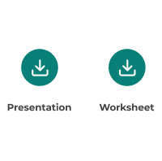

Save, share or download
With around 10,000 lessons available, and counting, you probably want to keep hold of the lessons you find and might like to use. You can now save lessons to your own private list, download the resources that the lessons make use of, and share links with your students more easily.

